WEEK ONE HOMEWORK FOR P.6 TERM 1 NO. 1
Name: …………………………………………………………………..stream: ……………………………..
SOCIAL STUDIES
- What is the compass direction of Kabale town from Kotido town?
- What title is given to the map that shows physical features?
- Name the first animal to be tamed by man.
- Which group of people introduced coffee growing in Uganda?
- How were most Bantu tribes politically organized?
- Who is the current prime minister of Uganda?
- Write UNBS in full.
- Which helper did Jesus promise his followers before ascension?
- On which day did the apostles receive the Holy Spirit?
MATHEMATICS
- Simplify: 6y – 3x – 2y + 5x
- Solve: 2x + 1 = 9
- The area of a rectangle is 32cm². If its length is 8cm, find its width.
- Musa is twice as old as his sister. Find the age of the sister, it their total age is 18 years.
- Collect like terms: 5a + 4b – 3a + b
- Given that x = 2, y = 3 and z = 5, find the value of:

- x + y + z
- xy – z
- y + z
x

- Find the value of w in diagram below.

7cm
4cm

(2w + 1) cm

- Solve 2a = 4
3

WEEK ONE HOMEWORK FOR P.6 TERM 1NO. 1
Name: …………………………………………………………………..stream: ……………………………..
SCIENCE
- What name is given to a castrated male bird?
- Identify any one breed of chicken kept for meat.
- Which system of poultry keeping is commonly used by commercial farmers?
- Why is it difficult to control diseases in birds under free range system?
- State one importance of litter in a deep litter house.
- Mention one protozoan poultry disease.
- How are grits in the alimentary canal of birds important to the birds?
- Name the poultry vice where birds peck and eat others.
- What is the importance of heat in an incubator?
- Study the farm record below and answer the questions that follow.
Date | Morning | Afternoon | No. of eggs broken | Total | Remarks
25.1.2016 | 50 | 45 | 5 | 90 | Poor handling of eggs
26.1.2016 | 55 | 46 | 2 | 99 | _do_
- What type of farm record is shown above?
- Give two reasons why farmers should keep records on their poultry farms.
ENGLISH
Use the given words correctly
- My father last ___________ a car in 2004. (buy)
- The parents waited ___________ for the meeting. (patient)
- Where __________ the party held? (be)
- These books belong to them. They are ___________. (they)
- Imran runs the ___________ in his school. (fast)
Fill in a correct word or a group of words
- There is ____________ apple and a cake in the bag.
- Most of the P.6 boys are fond ______ playing in classroom.
- Doctors don’t know the cause __________ cancer.
- There _______________ two boys in that room, weren’t there?
- ___________ does your sister go for computer lessons?

WEEK ONE HOMEWORK FOR P.6 TERM 1 NO. 2
Name: …………………………………………………………………..stream: ……………………………..
SOCIAL STUDIES
- What do we call the method of locating places on a map using longitudes and latitudes?
- Which type of rainfall is received around;

- Mountains
- Forests and lakes

- Name the dominant tribe living on the slopes of the Mufumbiro ranges?
- Why were political parties formed in Uganda in the 1950’s?
- Give any one good result of colonial rule in Uganda.
- Name the king of Buganda who ordered the killing of Christian converts.
- Name the ruling political party in Uganda.
- Name the prophet in Islam who is connected to Hadiths.
- Name the prophet in Christianity who baptized Jesus Christ.
MATHEMATICS
- Find the area of figures below.
(i) 10cm (ii)
6cm 8cm 7cm
4cm 5cm
6cm
- (iv)
4m
4.5cm 12m
- Find the area of the triangular flower garden whose base is 8cm and height 12m.
- Work out the length of the side of a square whose area is 64cm².
- Calculate the area of the shape below. 3dm
6dm
4dm
9dm

WEEK ONE HOMEWORK FOR P.6 TERM 1 NO. 2
Name: …………………………………………………………………..stream: ……………………………..
SCIENCE
- What name is given to a female sterile bee in a hive?
- Identify any one method of extracting honey.
- Give one reason why an apiary should be located away from homes and roads.
- Of what importance is a smoker to a honey harvester?
- How can farmers minimize swarming in their apiaries?
Below is the internal structure of a hive. Use it to answer questions 6 and 7.
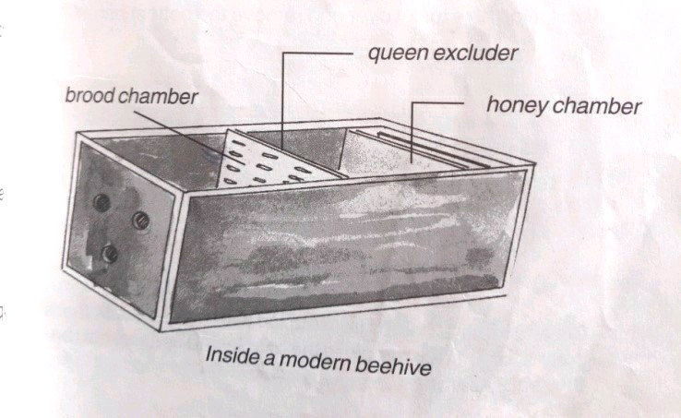
X

- Identify the type of bee hive above.
- How important is part X in the hive above?
- What enables worker bees to transport pollen to the hives?
- Mention one example of bee enemies.
- How are the following substances useful to bees?

- Propolis
- Nectar

- What name is given to the special food given to the queen bee?
ENGLISH
Write the following in full.

- Ltd
- doz
- MC

Give the plural form of the underlined words
- My aunt bought a sweet loaf of bread from the supermarket yesterday.
- The maid who served us was kind.
- Go to Bwindi, you will see a gorilla of a different size.

Give a single word for the underlined group of words
- The son of my brother was really very kind to his tenants.
- The book in which she writes her experience each day has gone missing.
- Our place where collection of books are kept is under repair.
- The headmistress was away for a period of two weeks after PLE.

WEEK TWO HOMEWORK FOR P.6 TERM 1 NO. 3
Name: …………………………………………………………………..stream: ……………………………..
SOCIAL STUDIES
- Which type of cattle was introduced by the Arabs in Uganda?
- Apart from the Arabs, name one other group of traders that came from Asia.
- State the major contribution of each of the following foreigners in Uganda.
- Mehta Khalida
- Aldina Visram
- What is vegetation?
- State one factor that influences the distribution of natural vegetation.
- How does the Equator influence climate?
- What important events took place in these places according to Islam and Christianity respectively?
- Mt. Hira
- Mt. Sinai
MATHEMATICS
- Find the area of the shaded area in the following figures. (2 marks each)
- . (b)

3dm
4dm
6dm
11m
4m

9dm 9m
(c).
4cm 8cm
3m

12cm
- A square carpet of side 5m, is centrally placed on a floor measuring 8m by 6m. Find the area of the floor not covered by the carpet. (2 marks)
- A photo measuring 12cm by 8cm is placed on to a frame measuring 20cm by 15cm. Calculate the area not covered by the photo.

WEEK TWO HOMEWORK FOR P.6 TERM 1 NO. 3
Name: …………………………………………………………………..stream: ……………………………..
SCIENCE
- What type of energy is possessed by water at O⁰C?
- Why do objects placed on water weigh less?
- Name the force that enables man to wash clothes.
- How does heat travel through an iron bar?
- Give one way in which radiation is important to crop farmers.
- What is matter?
- Give one effect of heat on matter.
- Which part of a thermos flask prevents heat loss or gain by conduction?
- Which state of matter has the greatest expansion rate?
- Using diagrams, show the difference in arrangement of molecules in the three states of matter.
- Jane’s temperature was measured by the school nurse and was found to be above the normal by 3⁰C. Convert Jane’s temperature to ⁰F.
ENGLISH
Fill in the blank spaces with a suitable word
- This is the boy __________ escaped from school yesterday.
- We have learnt English _________ forty minutes only.
- Most pupils go to school _______________ foot.
- Were _____________among the late-comers?
- We should ____________go to Eastern or Western on a study tour.
Re-write as instructed in brackets
- English is a very simple subject. Everybody will pass it. (Use: ------- such ----that ---)
- Mr. Mulondo has been a resident of this village since 2004. (Use: …….for ------)
- Charles is very good at playing volleyball. (Use: --------- interested --------)
- Kabuye is lazy. He can’t lift that box. (use: --------- enough -----------)
- Our monitor will be demoted by teachers if he misbehaves. (use: --------unless -----)

WEEK TWO HOMEWORK FOR P.6 TERM 1 NO. 4
Name: …………………………………………………………………..stream: ……………………………..
SOCIAL STUDIES
- How many countries share borders with Uganda?
- Mention at least two land locked neighbouring countries of Uganda.
- What are natural resources?
- Mention the most important natural resource.
- Why is the above resource regarded as the most important natural resource?
- What is Population density?
- Identify any one kind of information collected during the national census.
- Mention any two similar beliefs in both Christianity and Islam.

MATHEMATICS
- A maths lesson began at 9:10am and ended at 10:30am. How long was the lesson?
- Express the time “a quarter to 9 o’clock in the morning” in figures.
- Change the following time to 24 hour clock system.
- 5.30am
- 12.45pm
- 9.30pm
- Change the following to 12 hour clock.
- 17 15 hours
- 08 35 hours
- 00 40 hours
- Work out:
- Hrs min (b) Wks days
5 20 4 5
- 2 45 + 2 4

WEEK TWO HOMEWORK FOR P.6 TERM 1 NO. 4
Name: …………………………………………………………………..stream: ……………………………..
SCIENCE
- Which component of soil holds soil particles together?
- What is soil profile?
- Mention one mineral salt needed by plants.
- What does the experiment below prove about soil?
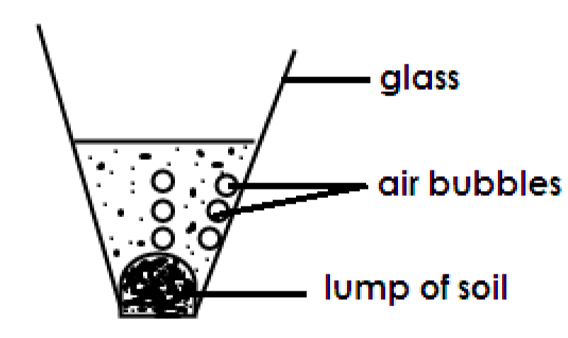

- Why is loam soil the best for crop growing?
- Write down one human activity that leads to soil erosion.
- Identify one method of controlling soil erosion in hilly areas.
- Define the following terms.

- Soil texture
- Soil structure
- Soil fertility

ENGLISH
Use the correct form of the given word to complete the sentences
- The robbers who broke into our school store were _________ to the police. (report)
- Kagoma is a ____________ . (Rwanda)
- Sheeba is _________________ than Sandra. (pretty)
- You are an ___________ if you are found driving while drunk. (offend)
- Thieves are fond of ____________ during Christmas season. (steal)
- Newsmen _____________ criticize governments. (open)
- Have you replied to her ________________? (invite)
- Kasamba always _________ when he sees the cartoons in the Monitor paper. (laugh)
- My shirt which was recently ____________ has been torn. (sew)
- The teacher told ___________ to go to the classroom. (we)

WEEK THREE HOMEWORK FOR P.6 TERM 1 NO. 5
Name: …………………………………………………………………..stream: ……………………………..
SOCIAL STUDIES
- What is an Ethnic group?
- To which ethnic grouping do the following tribes belong?
- Japadhola
- Bahima
- What are physical features?
- Why is the plateau also referred to as the “table-land”?
- Why is crop farming very difficult in Karamoja?
- How can farming be made easy in dry areas?
- Name the current Inspector General of Government (IGG) in Uganda.
- What is a talent?
- Give one example of talent.
MATHEMATICS
- Study the shopping bill and fill the gaps. (1 mark each)
Item | Quantity | Unit cost | Amount
Sugar | 2kg | Shs 2500 | Shs _________
Rice | 3 kg | Shs _________ | Shs 9000
Bread | _________ loaves | Shs 2000 | Shs 4000
Salt | 500gm | Shs 2000 | Shs ______
 |  | TOTAL | SHS ________

- Hamida went shopping and bought the following items.
- 3 apples at shs 2000.
- 1 ½ litres of milk at shs 1600 per litre.
- 2 bars of soap at shs 3000 each
- How much did she spend altogether?
- If she remained with shs 4600, how much did she have at first? (2 marks)

WEEK THREE HOMEWORK FOR P.6 TERM 1 NO. 5
Name: …………………………………………………………………..stream: ……………………………..
SCIENCE
- Identify one vaccine administered to babies at birth.
- Why are vaccines used in prevention of some diseases?
- Apart from immunization, mention one other way in which a baby’s immunity can be improved.
- Why has the government of Uganda made immunization free of charge?
- How are antibodies different from antigens?
- Mention one viral immunisable disease.
- Why are women of child-bearing age given T.T. vaccine?
- Apart from the eight infant killer immunisable diseases, mention one other immunisable disease.
- Define the following terms;
- Immunity
- Immunization

ENGLISH
Re-write the sentences giving the opposite of the underlined word.
- The literacy rate in Uganda is very high.
- The visiting team entered the football pitch first.
- The proposer was not given chance to defend his points.
- The ugliest boy in our class always arrives early.
- Most of the pupils in our school are very smart.
Write in full

- Rev. ______________
- Col. ______________
- Capt. _______________
- Hon. _______________
- H.E ______________

WEEK THREE HOMEWORK FOR P.6 TERM 1 NO. 6
Name: …………………………………………………………………..stream: ……………………………..
SOCIAL STUDIES
- What are non-traditional cash crops?
- How did Kenneth Borup promote the growing of traditional cash crops in Uganda?
- Give one advantage of growing coffee over growing beans.
- What is Government?
- Which arm of government is responsible for interpreting laws?
- Who was the first president of Uganda?
- Explain the following
- Communication
- Mass media
- How were the following people able to locate the birth place of Jesus?
- Magis
- Shepherds

MATHEMATICS
- The cost of 3 pens is shs 2400. Find the cost of 5 similar pens.
- Nakamwagi sells a heap of 5 tomatoes at shs 1000. How much money does she get from a basket containing 30 tomatoes? (2 marks)
- A dress was bought at shs 15000 and sold at a profit of 3000. Find the selling price.
- Jowelia sold a bag at shs 12000, making a loss of shs 3000. What was her buying price?
- The taxi fare from Kyengera to Kampala is shs 1000. If a taxi carried 14 passengers in a trip. How much money does a conductor get from 2 trips. (2 marks)
- A shopkeeper bought a dozen of exercise books at shs 5000. He sells each exercise book at shs 500. Calculate the profit he makes after selling the whole dozen. 3 marks)

WEEK THREE HOMEWORK FOR P.6 TERM 1 NO. 6
Name: …………………………………………………………………..stream: ……………………………..
SCIENCE
- Identify the mineral salt responsible for the formation of salivary amylase and hydrochloric acid.
- What is an enzyme?
- State any two characteristics of enzymes.
- How important is saliva during digestion of food?
- Suggest the importance of bile in the digestion of fats.
- Mention one disorder of the digestive system.
- Write down one adaptation of the ileum to absorption of digested food.
- Below is part of the digestive system. Use it to answer questions that follow.
- Which class of food is digested in part marked X?
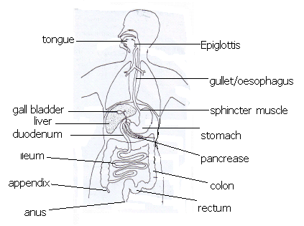
- Name the digestive juice produced by organ X.
- Name one disease of the digestive system which affects organ marked X.
X

ENGLISH
Re-write as instructed in brackets
- Although the teacher advised the boy to stop arguing, he just continued . (Re-write as two separate sentences)
- He removes his clothes. Then he starts swimming. (Join using: -------after -------)
- Joyce is not good at Maths. Jane is not good at Maths. (use: -------neither ---nor
- I intend to buy a new bicycle. (Begin: My ----------------)
- His roof was blown off by a strong wind. (End ------- his roof)
Give the plural of ;

- a loaf of bread
- a goose
- a housewife
- a leaf
- a sheep

WEEK FOUR HOMEWORK FOR P.6 TERM 1 NO. 7
Name: …………………………………………………………………..stream: ……………………………..
SOCIAL STUDIES
- What is a common market?
- In which year was the current East African Community revived?
- Give two ways the people of East Africa benefit from EAC.
- Which imaginary lines are also known as “Parallels”?
- What is a Time zone?
- In which time zone is E. Africa found?
- If it is 7:15am at Greenwich meridian. What time will it be at a place located 45⁰E?
- What term is used to refer to:
- Followers of Prophet Mohammed.
- Successors of Prophet Mohammed.
MATHEMATICS
- Find the value of y in diagrams.
3y
3y
2y
y
(ii)
(iii)

2y
70⁰
50⁰
50⁰
- Study the figure below and use it to answer questions that follow.
E
A
- Give any pair of lines which are;
- Parallel
- Skew
- Perpendicular

F
4cm
D
5cm
C
G
6cm

(b) Work out:
(i) the volume (2 marks)
(ii) its total surface area. (2 marks)

WEEK FOUR HOMEWORK FOR P.6 TERM 1 NO. 7
Name: …………………………………………………………………..stream: ……………………………..
SCIENCE
- What are vertebrates?
- In which way are plants different from animals in terms of feeding?
- Why are mammals regarded as warm-blooded vertebrates?
- Mention one example of an egg-laying mammal.
- Why are bats regarded as mammals?
- Suggest one characteristic of carnivorous mammals.
- Mention one example of nocturnal animals.
- How are sea mammals kept warm?
- For each of the class of mammals given below, identify one example.
- Marsupials
- Monotremes

ENGLISH
Fill in the spaces with the correct letters to make meaningful words

- m__to__i__t
- s__gn__l
- cycli___ ___
- s___ ___tb___ ___t
- acc___ ___en___s

Re-write as instructed in brackets
- Angella drove the van very carefully. All the passengers praised her. (Use: ----- so ------ that --------)
- Bosco saw the speeding vehicle and stepped aside. (Use: --------so ----------)
- Mr. Lule teaches his children the highway code. Mr. Lule wants his children to avoid accidents on the road. (Use: ----- because ---------)
- Do not drive fast as you approach a zebra-crossing. (Use: ‘slow down’)
- The bus stopped and the passengers boarded. (use: ------- as soon as --------)

WEEK FOUR HOMEWORK FOR P.6 TERM 1 NO. 8
Name: …………………………………………………………………..stream: ……………………………..
SOCIAL STUDIES
- Name the earliest ethnic group of East Africa.
- Through which country did the Bantu enter Uganda?
- Name the last Bantu tribe to migrate into East Africa.
- Which kingdom existed in Western Kenya?
- What title was given to the rulers of the above kingdom?
- Name the tribe in East Africa whose leaders are termed as Ntemi.
- What is a National budget?
- Give one reason government makes a national budget.
- What title is given to the head of all Catholic believers in the world?
- What title is given to the head of all Muslims in Uganda?
MATHEMATICS
- Rachael was facing East and turned through an angle of 135⁰ anticlockwise. What was her new direction?
- Give the lines of symmetry in each of the following shapes;
(i). (ii) (iii)

- Give the complement of 59⁰.
- Find the value of angle X.
x
50⁰
- The area of a square is 49²m. Find its perimeter. (2 marks)
- Using a protractor, measure the angles below.
(i). (ii)

WEEK FOUR HOMEWORK FOR P.6 TERM 1 NO. 8
Name: …………………………………………………………………..stream: ……………………………..
SCIENCE
- Give one reason why animals move from one place to another.
- How are birds adapted to flying?
- Apart from holding the yolk and the embryo in position, identify one other function of the chalaza to the embryo.
- Mention the type of feathers chicks hatch with.
- Give one way in which scavenger birds are important in the environment.
- Why don’t carnivorous birds have crops?
Study the diagram below and answer questions 7 and 8.
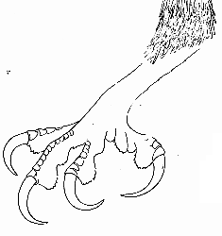

- Identify the group of birds with such a foot.
- Mention one example of birds in the group above.
- Why do wading birds have long legs?
- How are scavenger birds different from preying birds?

ENGLISH
Complete the table
Infinitive | Continuous | Past | Participate
- Die
- Dye
- Shine
- Tear
- Dream
Join the following sentences using: Although ------------
- The army was well trained. It failed to win the battle.
- She defended herself. She was hurt.
- She is not a suspect. She is detained at the police station.
- Wilber was taught how to keep peace. He is still violent.
- The pupils worked hard. They did not pass.

WEEK FIVE HOMEWORK FOR P.6 TERM 1 NO. 9
Name: …………………………………………………………………..stream: ……………………………..
SOCIAL STUDIES
- What is climate?
- Mention any one district in Uganda with Equatorial climate.
- Why is Mombasa hotter than Kampala although it is near the Indian Ocean?
- Give one reason why climate varies from place to place.
- Apart from trading, state one other reason why Arabs came to East Africa.
- What was the first form of money to be used in East Africa?
- Give one major reason why the following are remembered in Uganda’s history.
- I.K Musaazi
- Benedicto Kiwanuka
- Write down one way a Christian can communicate to God.
- Which type of prayers is the Lord’s Prayer?
MATHEMATICS

- Name the given type of sets below.
A B
1 a
2 b
3 c
4 d
- Given that sets
P = {p, q, r, s, t}
N = {k, l, m, r, s}
- Represent the above information on the venn diagram below.
ε =
P N

- List members of;
- P n N
- P U N
- P – N
- N – P
- Name the shaded regions
ε=
K L

ε =
A B

WEEK FIVE HOMEWORK FOR P.6 TERM 1 NO. 9
Name: …………………………………………………………………..stream: ……………………………..
SCIENCE
- Mention one reptile that lives both on land and in water.
- Why are reptiles said to be cold blooded animals?
- How would you differentiate a poisonous snake from a non poisonous snake?
- State one example of non-poisonous snakes.
- Why is it advisable to tie between the bitten part and the heart when administering first aid for snake bite?
- What is the importance of geckoes in a residential house?
- What adaptation enables geckoes to move upside down on ceilings without falling?
- The diagram below shows the head of a poisonous snake. Use it to answer questions that follow. Y
- Name the parts labelled
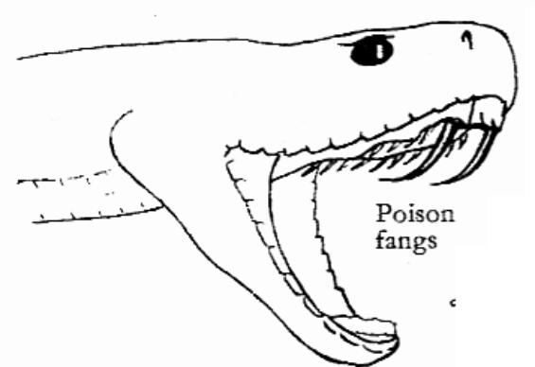
- X (ii) Y
- Of what importance are parts X and Y to the snake?
X
- X (ii) Y

ENGLISH
Use the words in brackets in past simple tense.
- The traffic officer ___________ the drunken driver. (arrest)
- Jacob, the police officer, ___________ to London last week. (fly)
- The money the suspect ____________ is known as the bail. (pay)
- All the suspects ___________ here yesterday. (sleep)
- Mayanja ____________ the handcuffs. (carry)
- The O.C _____________ us how to keep peace in our society. (teach)
- The soldiers __________ the pastor in the cell. (lock)
- Atwine ___________ the stolen items in the rubbish pit. (throw)
- I ____________ the officer’s juice yesterday. (drink)
- Is it true that the army ___________ baskets last month? (weave)

WEEK FIVE HOMEWORK FOR P.6 TERM 1 NO. 10
Name: …………………………………………………………………..stream: ……………………………..
SOCIAL STUDIES
- What is trade?
- Differentiate between slave trade and slavery.
- Name the sea port that handles most of Uganda’s imports and exports.
- Give one way the EAC has developed trade in East Africa.
- In which year did Rwanda and Burundi join the EAC?
- Name the district where the headquarters of the East African Civil Aviation Authority is found.
- Why is cattle keeping difficult in Miombo woodlands?
- What main economic activity is carried out in Miombo woodland in central Tanzania?
- What is Reconciliation?
- How did God show love and reconciliation with man after the original sin?
MATHEMATICS
- List all subsets from the given sets below.
- P = {1, 3, 6}
- Q = {a, e, i, o}
- Using the formular find the number of subsets in the sets with;
- 3 elements
- 4 elements
- Work out the number of proper subsets in the given sets.
K =

L = {1, 2, 3, 4, 5}
- Draw venn diagram to show that;
- All boys (B) are males (m)
- All cows (c ) are animals (A)

WEEK FIVE HOMEWORK FOR P.6 TERM 1 NO. 10
Name: …………………………………………………………………..stream: ……………………………..
SCIENCE
- Name one example of an amphibian.
- How is breathing of a tadpole different from that of an adult frog?
- What type of fertilization do amphibians under go?
- Suggest the importance of a stream-lined body shape to a frog and fish.
- State one reason toads lay very many eggs.
- Which group of vertebrates spends its early stage of development in water?

- Below are eggs of amphibians. Use them to answer questions that follow.
M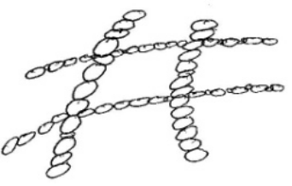 N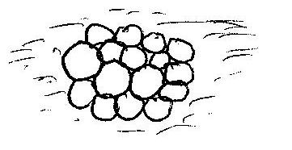
- Name the amphibian which lays eggs labelled
- M: _____ (ii) N: ____
- How are such eggs protected from predators?
ENGLISH
The dialogue below took place between the chairman LCI and Luzinda who was suspected to have kidnapped a child. Fill in what you think Luzinda said.
Chairman : What is your name?
Luzinda : ____________________________________________________
Chairman : Where do you live?
Luzinda : ____________________________________________________
Chairman : Just here in Nyondo? What is your father’s name?
Luzinda : ____________________________________________________
Chairman : Mr. Tembo who repairs saucepans! What were you doing at Kipusu’s home?
Luzinda : ____________________________________________________
Chairman : Playing at that time of the night?
Where s Kipusu’s son?
Luzinda : ____________________________________________________
Chairman : You don’t know! Whom were you playing with?
Luzinda : ____________________________________________________
Chairman : Then if you were playing with Aki, where was the brother at that time?
Luzinda : ____________________________________________________
Chairman : if he was seated looking at you, how comes he disappeared when you left?
Luzinda : ____________________________________________________

WEEK SIX HOMEWORK FOR P.6 TERM 1 NO. 11
Name: …………………………………………………………………..stream: ……………………………..
SOCIAL STUDIES
- Name the main source of soda ash in Kenya.
- Why is there no fish in lake katwe?
- Write down three countries that share Lake Tanganyika.
- Why is there very little rainfall in the north eastern parts of Kenya?
- Describe these climatic zones.

- Equatorial climate
- Semi desert climate

- Who is a prophet?
- How is prophet Isaiah linked to the coming of the saviour according to the Bible?

MATHEMATICS
- Given that
Set N = {prime numbers between 0 and 12}
P = { 1, 2, 3, 4, 5, 6}
- Represent the above information on the venn diagram below.
ε =
N P

- Find;

- n (N n P)
- n (P – N)
- n (N – P)
- n (N u P)

- Given that n (A) = 10, n (B) = 15 n (A n B) = 2, and n (A u B)’ = 2
- Represent the above information on the venn diagram below.
n(A)____ n(B)____
____ __ ___
____
- Find n (ε)

WEEK SIX HOMEWORK FOR P.6 TERM 1 NO. 11
Name: …………………………………………………………………..stream: …………………………..
SCIENCE
- What does the term invertebrates mean?
- State the type of skeleton common in insects.
- How are lung hooks important to spiders?
- To which group of invertebrates does a millipede belong?
- Suggest one characteristic common in all arthropods.
- On which body part of a spider are legs attached?
Below is a diagram of a certain worm. Use it to answer questions 7 to 9.
- What general name is given to part A?
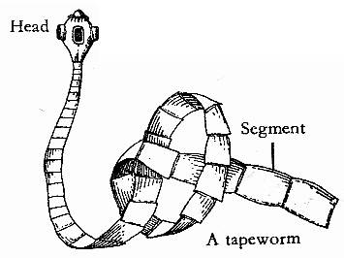
A
- How does the above worm eater the body.
- State one way of preventing tape-worm infection.

- Identify any one mollusc vector.
ENGLISH
Write a letter to the O.C Kikiri Police Station P. O. Box 344, Kumi, informing him about the increased number of idlers in your village who are taking drugs on a daily basis. Express how worried you are and why. (Use your village address)
______________________________________________________________________________________________________________________________________________________________________________________________________________________________________________________________________________________________________________________________________________________________________________________________________________________________________________________
___________________________________________________________________________________________________________________________________________________________________________________________________________________________

WEEK SIX HOMEWORK FOR P.6 TERM 1 NO. 12
Name: …………………………………………………………………..stream: ……………………………..
SOCIAL STUDIES
- What is migration?
- State two causes of early ethnic migrations.
- Name the oldest kingdom in East Africa.
- What is meant by interlacustrine region?
- Why did the Bantu settle in the interlacustrine region?
- What is commercial farming?
- How is it difficult to use tractors to cultivate land in Kabale district?
- Identify the main cause of land fragmentation in East Africa.
- What is a sacrament?
- Mention the first sacrament in Christian faith.
MATHEMATICS
- In a class, 16 pupils like English (E), 20 pupils like Maths (M) and 3 pupils like both English and Maths.
- Represent the above information on the venn diagram below.
n(ε) (b) Find
n(E) _____ n(M) _____ (ii) n(ε) =
____ ___ ____ (ii) How many pupils like
Only one subject.
- In a class of 40 pupils , 30 take Fanta (F), 20 take Pepsi cola (P). Some take both drinks while 4 take neither of the drinks.
- Show the above information on the venn diagram.
n(ε)
n(F) _____ n(P) ___
____ ___ ____

- How many pupils like both drinks?
- What is the probability of picking a member who takes only one type of drinks?

WEEK SIX HOMEWORK FOR P.6 TERM 1 NO. 12
Name: …………………………………………………………………..stream: ……………………………..
SCIENCE
- State one importance of feelers to insects.
- Give one body characteristic common to a spider and a tick.
- Suggest one activity done at home to control the spread of malaria.
- Which mosquito lays the eggs drawn below?
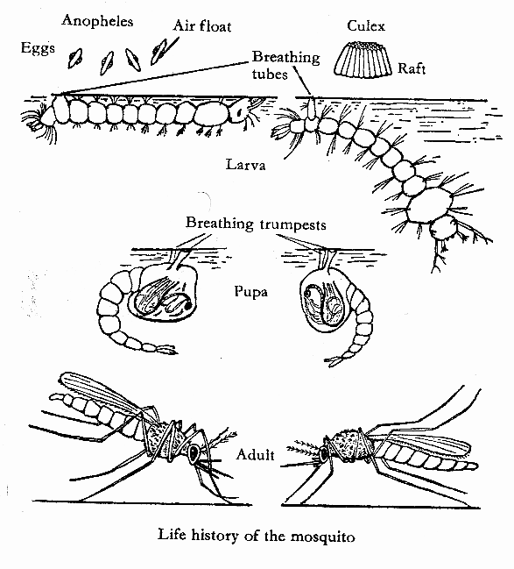

- How is the larva stage of a moth dangerous to crops?
- Why is it dangerous to pour paraffin in a pit latrine?
- How do hook worms enter our bodies?
- In which way are suction pads important to a housefly?
- Why do houseflies lay their eggs on decaying matter?
- Give one example roundworms.

ENGLISH
Re-write the sentences given below as instructed in brackets
- That is the man. He stole my bicycle. (Use: ------ who ----------)
- I did not steal your pawpaws. (Begin: I have -------------)
- He is very merciless. He robbed the poor widow. (Use: -------- so --------- that -----)
- That is the place. The cyclist was killed from there. (use: --------- where ----------)
- When I saw the suspect, I arrested him. (Use: -------as soon as ----------)
- Joan met the officer. He greeted her. (Use: --------- and ---------)
- Masika was not robbed. Andrew was not robbed. (Begin: Neither ------------)
- The evidence is relevant. It can help you win the case. (Use: ---- enough ----------)
- Here comes the lady. Her phone was stolen. (------- whose --------)

WEEK SEVEN HOMEWORK FOR P.6 TERM 1 NO. 13
Name: …………………………………………………………………..stream: ……………………………..
SOCIAL STUDIES
- Name one pastoral tribe in Kenya.
- Which lake in East Africa is known as a bird sanctuary?
- What is tourism?
- Mention the major tourist attraction in the following areas;
- Nyero stone age site
- Lake Nakuru national park
- Draw and name the road sign for “No parking”
- Why is East Africa referred to as the “cradle of man”?
- Name the largest game park in East Africa.
- Who was the first wife of Prophet Mohammed?
- What was the occupation of Prophet Mohammed before Allah’s call?
MATHEMATICS
- Expand the following numbers using place values.
- 7 8 9 3
- 6 3 7.4
- Expand 3463 using powers of ten.
- Find the expanded numbers
- (7 x 1000) + (4 x 10) + (3 x 1)
- (4 x 10⁴) + (3 x 10²) + (2 x 10⁰)
- Find the sum of the values of 4 and 6 in 34163
- Find the product of the value of 3 and the place value of 4 in 73641.
- Work out the difference of the largest and the smallest number that can be got from the digits below.
7, 3, 2, 4

WEEK SEVEN HOMEWORK FOR P.6 TERM 1 NO. 13
Name: …………………………………………………………………..stream: ……………………………..
SCIENCE
- Which body organ uses sound energy to function?
- How does sound travel from the source to the receiver?
- Mention one artificial source of sound energy.
- Why do we see lightning before hearing thunder?
- Mention one factor that affects pitch of sound.
Use the waves below to answer questions 6 and 7.
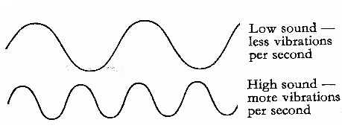
A

B

- Which of the two waves shows sound of the highest pitch?
- Give the reason to support your answer in 6 above.
- Give the meaning of the following terms as used in sound energy.

- Pitch
- Volume
- Frequency
- Echo

ENGLISH
Re-write the sentences as instructed in brackets
- He is a very tired guard. He cannot take care of the prisoners. (Use: ------ such a ----that ---------)
- The police officer listened to me. The police constable listened to me. (Begin; Both ---)
- Set a thief -------------------------- (Complete the saying)
- The chief used my handkerchief to tie the thief. (Rewrite the sentence in plural)
- A prefect has brought back my book. (Begin; My book --------------)
- “I am looking for the suspect,” said Bugembe. (Begin: Bugembe said that -----)
- Jeff is too young to go to the police post alone. (Re-write as two separate sentences
- This is the car. They destroyed it. (Use: ---------which -----------)
- The police was around. The robber was burnt to death. (begin: Although ------)

WEEK SEVEN HOMEWORK FOR P.6 TERM 1 NO. 14
Name: …………………………………………………………………..stream: ……………………………..
SOCIAL STUDIES
- What is irrigation farming?
- Why is irrigation farming not needed on the slopes of Mt. Elgon?
- Name the deepest lake in East Africa.
- Which type of vegetation is found on the coastal areas of East Africa?
- Why is timber from the vegetation above suitable for boat making?
- Mention one way the Bagisu are similar to the Chagga in terms of economic activities.
- Why did foreigners take long to come to the interior of East Africa?
- Mention the raw material for cigarette-making.
- Which foreign religion was introduced in East Africa before Christianity?
- Why did the above religion take longer time to spread than Christianity in East Africa?
MATHEMATICS
- Write each of the following figures in words:
- 1,054,321 (b) 98,765
- Write the following numbers in figures.
- Three million, thirty thousand thirty three
- One hundred two thousand, two
- Convert the following to Roman numerals.
- 94 (b) 468
- Convert to Hindu Arabic numerals.
- CDXCIV (b) CMXLIX
- Mr. Opio was born in MCMLXII. How old is he this year? (give your answer in Roman. ( 2 marks)

WEEK SEVEN HOMEWORK FOR P.6 TERM 1 NO. 14
Name: …………………………………………………………………..stream: ……………………………..

SCIENCE
- State one device used to store sound.
- In which two ways can sound be reproduced?
- Suggest the basic units for measuring sound energy.
- Why should sound energy be stored and reproduced?
- It took jack 4 seconds to hear a clap from his sister. How far was he from the sister?
Below is a musical instrument. Use it to answer questions 6 to 8.
- Name the musical instrument drawn above.
- How does the above musical instrument produce sound?
2
3
4
5
- Give one way through which sound from the musical instrument can be stored.
1
- In which state of matter does sound travel fastest?
- Why doesn’t sound travel through a vacuum?

ENGLISH
Use the given words correctly
- The criminal _________________ money everyday. (forge)
- That cashier is not so good but she _________ (try)
- Most of the workers in that bank _____________ their manager. (obey)
- The security guard ____________ a gun daily. (carry)
- Lususu _____________ like tellers. (dress)
- Diego _______________ with Stanbic. (bank)
- Alvin ____________ to City bank almost everyday. (go)
- Every cashier must ______________ for every single shilling. (account)
- That lady ______________ books of account in that bank daily. (balance)
- The bank manager always _____________ issues with his deputy before implementing them. (discuss)

WEEK EIGHT HOMEWORK FOR P.6 TERM 1 NO. 15
Name: …………………………………………………………………..stream: ……………………………..
SOCIAL STUDIES
- Which organ of the East African Community is responsible for day to day affairs of the organization?
- Name the current presidents of these countries;
- Burundi
- Tanzania
- Name the bank through which the EAC provides loans to member states to carryout development projects.
- In which city is the headquarters of the bank above?
- How important is Arusha town to the East African Community?
- What are perennial crops?
- Which perennial crop is commonly grown on the slopes of Mt. Kilimanjaro?
- What is meant by the Holy Trinity in Christian faith?
- Write down any one function of the third person in the Holy Trinity.
MATHEMATICS
- Add:
- 3,143,526 + 4,632,453

- 7,654,321 (c) 4,743,127
+ 4,567,890 + 582,684

- In a forest, there are 2,953,279 pine trees, 840,158 Cyprus tress and 75,083 Musizi trees. How many trees are in the forest altogether?
- Subtract:
- 5,987,432 – 654,321

- 9,048,521 (c) 112,053
- 672,409 - 98,765

- The population in a certain district was 1,502,862. If 694,583 were male how many female were in that district? (2 marks)

WEEK EIGHT HOMEWORK FOR P.6 TERM 1 NO. 15
Name: …………………………………………………………………..stream: ……………………………..
SCIENCE
- Apart from hearing, state one other function of the ear.
- How important is sound to animals?
- Which part of the ear is full of fluid?
- Why is it dangerous to clean the ear using sharp objects?
- Of what value is wax to the human ear?
Below is part of the human ear. Use it to answer question 6 to 8.
X
- Name the part labelled X.
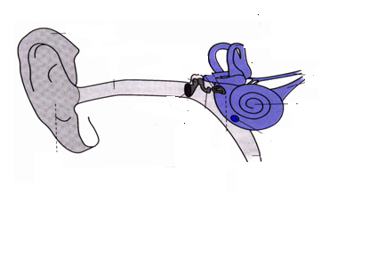
- How important is part X to the ear?
- Mention one disease of the ear.

- Akoth has got a small insect in her ear. What advice do you give her?
- Which part on the body of a frog does it use to hear sound waves?

ENGLISH
Use the given words correctly
- Netball players should always respect ___________ while they are playing. (they)
- My uncle ___________ my fees last term. (pay)
- Before you go to the market, you should prepare a ___________ list. (shop)
- We eat chicken ___________ a week. (one)
- There is a lot of ___________ among the youths in our village. (poor)
- Amos is fond of buying _______________ things. (luxury)
- The monkey ___________ climbed the mountain up to the highest point. (slow)
- Some _________ often fail to observe the traffic regulations. (cycle)
- Trees drop off their _____________ in dry season. (leaf)
- When the guest arrived, Otada was __________ a story book. (read)

WEEK EIGHT HOMEWORK FOR P.6 TERM 1 NO. 16
Name: …………………………………………………………………..stream: ……………………………..
SOCIAL STUDIES
- State the effect of the rotation of the earth on its axis.

- What is meant by Equinox?
- Name the inland ports of lake Victoria marked below
M
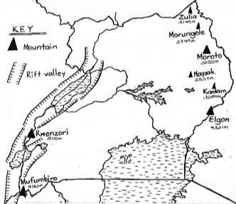
Page

24

Major mountains in Uganda.

- What is the chief cash crop grown in Kericho district of Kenya?
- Name the river used as a natural boundary in Tanzania.
- What does Blue on the EAC flag represent?
- Give the meaning of;
- Sabbath
- Moses

MATHEMATICS
- Find the product of the following
(a) 1 3 4 5 (b) 2 4 5 6 (c) 1 5 4 8
X 2 4 x 3 6 x 1 2 6

(2 mark each)
- There are 2,135 pupils in Sir Apollo – Mengo. If each pupil is given 36 exercise books, how many books are given out altogether? (2marks)
- There are 144 items in a gross. How many items are in 154 grosses? ( 2 marks)

WEEK EIGHT HOMEWORK FOR P.6 TERM 1 NO. 16
Name: …………………………………………………………………..stream: ……………………………..
SCIENCE
- Mention any one component of the circulatory system.
- How important is the circulatory system in the body?
- State the main function of the heart.
- State the functional difference between pulmonary vein and pulmonary artery.
- Suggest the importance of blood cells below.

- Why is blood pumped to the lungs before flowing to other parts of the body?
- How is the left side of the heart adapted to its work of pumping blood at high pressure?
- Give one way in which PIASCY messages are important to the youth.

ENGLISH
Fill in the gaps correctly
- Mulefu was accused ______________ stealing a pen.
- Emmanuel is _____________ university student now.
- The girls __________ playing netball when it started raining.
- Sarah has been crying ____________ two hours.
- The pineapple was ______________ expensive for me to buy.
Re-arrange the given words in alphabetical order.
- beans, bean, feast, curd
- albion, albinism, albeit, albino
Use the given words in a sentence each to show their meanings.
- brake
- break
- brick

WEEK NINE HOMEWORK FOR P.6 TERM 1 NO. 17
Name: …………………………………………………………………..stream: ……………………………..
SOCIAL STUDIES
- What was Long Distance trade?
- How was long distance trade conducted before the introduction of cowrie shells?
- Name the tribe in Kenya which actively participated in long distance trade.
- Why did the Nilotics change from predominant pastoralism to mixed farming?
- Which country is bordered by Uganda to the west?
- Which rift valley lake in Kenya is known as “Rudolf”?
- Name the current chairperson of the East African community.
- Give one factor that led to the collapse of EAC.
- Which prophets received these books?
- Injir
- Tauret

MATHEMATICS
- Work out the following

(a). 24 16,824 (b) 25 875,000

- 18 44,208

- The Ministry of Education distributed equally 9,270 computers among 15 districts. How many computers did each district get?
- Work out the following
- 1 of 15 + 20 ÷ 4
3

- 7 – 9 + (18 ÷ 3)

WEEK NINE HOMEWORK FOR P.6 TERM 1 NO. 17
Name: …………………………………………………………………..stream: ……………………………..
SCIENCE
- Identify the component of blood responsible for transporting digested food in the body.
- How is the skeletal system important to the circulatory system?
- Write down one disease of the circulatory system that results from abnormal rate at which the heart pumps blood.
- Give one importance of haemoglobin found in the red blood cells.
- Which blood vessel carries digested food from the intestines to the liver?
- What can an individual do to keep his circulatory system functioning normally?
- Mention two hereditary diseases that affect the circulatory system.
Below is a vein, use it to answer questions that follow.
- Name the structures marked X.
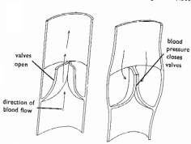
X
- Of what use is part marked X to the vein?

ENGLISH
Re-arrange the given sentences to form a short story
- The third man asked the driver to stop.
- It started crying until everybody became concerned.
- I sat next to a woman who had a baby.
- Another one asked whether the baby was hers.
- Last Sunday, I took a taxi to the village.
- When the taxi stopped, the woman could not explain why she was not breastfeeding the baby.
- As we approached Kagadi, the baby woke up.
- One of the men asked her why she could not breast feed the baby.
- The baby was asleep.
- People asked the taxi-driver to drive to the nearest police station.

WEEK NINE HOMEWORK FOR P.6 TERM 1 NO. 18
Name: …………………………………………………………………..stream: ……………………………..
SOCIAL STUDIES
- Apart from a school uniform, give any other symbol of a school.
- Suggest one problem a country with low population faces.
- Of what value is the thick bark to a cactus tree?
- What are deciduous trees?
- What is meteorology?
- Write down two weather instruments that are kept in the Stevenson screen.
- Name the highest court of law in East Africa.
- Name the writers of the following books;
- Mark
- Genesis.
MATHEMATICS
- Identify the numbers which are divisible by 3. (show the working)
313, 111, 166, 135, 155

- Work out the square roots of the following;
(a) 36 (b) 9 (c) 12 ¼
16
- Find the squares of the following;
- 4 (b) 11
9
- Fill in the missing numbers in the sequences below.
- 1, 3, 5, 7, ________
- 16, 25, 36, 49, _________
- 1, 3, 6, 10, 15, __________

WEEK NINE HOMEWORK FOR P.6 TERM 1 NO. 18
Name: …………………………………………………………………..stream: ……………………………..
SCIENCE
- State the main function of the red blood cells in the body.
- Give one way in which red blood cells are able to carry oxygen to all body parts.
- What special name is given to the upper chambers of the heart?
- Why does blood go to the lungs before it circulates to all body parts?
- What is double circulation?
- Why is Sir William Harvey remembered in the history of Science?
- How is a stethoscope important to a doctor?
- Give one functional difference between red blood cells and white blood cells.
- What disease results from a deficiency of iron in the body?
- Name any one disease related to blood.

ENGLISH
Re-write the sentences as instructed in brackets
- His son cleans the workshop every evening. (Begin: The workshop --------------)
- My aunt was very principled. She could not accept any bride. ( use: ---- so ---that ---
- Not only is Phillip noisy but also lousy. (Use: ----------- both ------------)
- I like knitting. I like weaving more. (Use: ------------ prefer ----------)
- There comes the man. The man raped a school girl. (Use: ---- who ------)
- Byaruhanga was too busy to complete his meal. (Re-write as two separate sentences )
- One by one , --------------- (Complete the saying )
- Kayondo should cross the road only when it is very clear. (Use: -------- must ---- unless ------------)
- Rita is a very good mechanic. Paul is also a very good mechanic. (Join using; ------ and ----)

WEEK TEN HOMEWORK FOR P.6 TERM 1 NO. 19
Name: …………………………………………………………………..stream: ……………………………..
SOCIAL STUDIES
- What is population distribution?
- State any two factors that determine population distribution.
- Write IBEACo in full.
- What were the functions of the IBEACo in Uganda? (Give two)
- Write one reason why IBEACo ran bankrupt.
- What title was given to the British representatives in Uganda before they were called governors?
- Give two advantages of indirect rule over direct rule to the colonialists.
- What is important about these days in Christianity?
- Pentecost Day
- Good Friday

MATHEMATICS
- Work out the LCM of 8 and 12.
- Find the least number of sweets which when shared between either 3 or 4 girls leaves a remainder of 2 sweets.
- (a) The sum of 3 consecutive odd numbers is 69. What are the numbers?
(b) Find their average.
4. The LCM of two numbers is 36 and their GCF is 6. If one of the numbers is 12, find the second number.

WEEK TEN HOMEWORK FOR P.6 TERM 1 NO. 19
Name: …………………………………………………………………..stream: ……………………………..
SCIENCE
- Write down any one method used in making alcohol.
- Why is alcohol collected off first during the distillation process?
- Give any one long term effect of prolonged use of alcohol by an individual.
- How does alcoholism affect family members?
- Name the dangerous gas found in tobacco.
- What is drug abuse?
- State one way alcoholism is dangerous to a pregnant woman.
- Mention one way in which drug prescription is important to a patient.
- Why should drugs be kept out of reach of children?
- List down three examples of drugs commonly abused in Uganda.
ENGLISH
Re-write as instructed in brackets
- Immediately the mother went to bed, the girls jumped through the window. (Begin: No sooner ---------------)
- james friend didn’t die in nsambya hospital. (punctuate)
- She has a degree but she doesn’t have a job. (Despite -------------)
- I last met my uncle two years ago. (Use: -------- since --------------)
- The driver was driving under the influence of alcohol. He caused the accident. (Use: --------- because ----------)
- They sang the National Anthem and the debate started. (Use: Before ----------)
- Mr. Kamari is a driver. Mr. Kamari is a conductor. (Use: -------- both ---------)
- The pupils were very tired. They could not go on with the debate. (Use ------ too ---- to --------)
- I borrowed one million shillings from my aunt. (Begin: My aunt ----------)

WEEK TEN HOMEWORK FOR P.6 TERM 1 NO. 20
Name: …………………………………………………………………..stream: ……………………………..
SOCIAL STUDIES
- What are basic needs?
- State one example of basic needs.
- What are Human rights?
- Give two examples of fundamental human rights.
- What is a by-law?
- Explain the following terms.
- Bill
- Hansard
- What is Zakat?
- Give one kind of item a Muslim can offer as Zakat.

MATHEMATICS
- Find the GCF of 18 and 24.
- What number has been prime factorised to give: {2₁, 2₂, 3₁, 3₂)
- Study the venn diagram and use it to answer questions that follow.
F₂₄ F_{X}
2₁
2₃ 2₂ 3₂
3₁

- Find the value of X.
- Work out:
- The GCF of 24 and X
- The LCM of 24 and x.
- If 2² x y = 28, find the value of y.

WEEK TEN HOMEWORK FOR P.6 TERM 1 NO. 20
Name: …………………………………………………………………..stream: ……………………………..
SCIENCE
- Identify one life skill that can help one to stop drug abuse.
- Give one way in which drugs are commonly abused in Uganda.
- How does alcoholism lead to under development in a community?
- Give one immediate effect of alcoholism to an individual.
- List down any two body organs destroyed by taking too much alcohol.
- Write down an example of essential drugs under each category below.
- Pain killers
- Anti-biotics
- Anti-malarials
- Traditional essential drugs
ENGLISH
The sentences below are in wrong order
Re-arrange them to form a good composition.
- Theft eventually became part of him and unfortunately, he was arrested one day.
- Suddenly, they never gave him a second chance only to make him run mad.
- This peer group spoilt him by teaching him how to use drugs.
- Time reached when he couldn’t live without them.
- Chandit is now one of the mad people on the streets as a result of taking drugs.
- He learnt how to use drugs and got used to them.
- Chandit used to be a well behaved boy before he joined a bad peer group.
- When he was set free, he resumed to taking them as if the punishment wasn’t enough.
- This forced him to do sinful acts like stealing in order to get the money to buy them.
- He served the sentence in prison after being found guilty.

